|  |  |
| --- | --- |
| **VMP** | VMP / QA / R / 05 |
| REV.NO :1.0 |
| Page 1 |
| Date: 31.01.2020 |

# 

# Campaign Batch Schedule – Final Check List

**Document Version Information**

|  |  |  |  |
| --- | --- | --- | --- |
| Project Name | Intel | Doc Version No | 1 |
| Document Title | dcai_APJ_dcaiesg_EMPE_EN_2024_Gen AI Web On-Demand eDM3_C-MKA-40644_T-MKA-40770 | Preparation Date | 29-01-24 |
| Prepared/Updated By | Prakash Kumar M | Review Date | 29-01-24 |
| Reviewed By | Swati |  |  |

**Revision History**

|  |  |  |  |  |
| --- | --- | --- | --- | --- |
| S.no | Description | Update By & Date | Approval By | Comments |
|  |  |  |  |  |
|  |  |  |  |  |
|  |  |  |  |  |

|  |  |
| --- | --- |
| Client Name | Intel |
| Campaign /Eloqua Brochure Name | dcai_APJ_dcaiesg_EMPE_EN_2024_Gen AI Web On-Demand eDM3_C-MKA-40644_T-MKA-40770 |
| Is it a Nurture Campaign? | NA |
| If yes, please update the Nurture Campaign Ending Date (Always-on or End date to be specified) | NA |
| Respective Notification mails are enabled and checked for Nurture Campaigns? | NA |
| If APJ CMX nurture, ensure this nurture is excluded in AEN nurture i.e., update the shared filter - AEN Nurture_MKA-24838 | NA |
| If APJ CMX nurture, Have we checked with CSM if DCAI nurture need to be Excluded in this nurture?  If Yes, Exclude the Shared List - In-Nurture Entry Shared list in Segment | NA |
| Is Email throttle step added before each email send step? | Yes |
| If Throttle step is added, check if there is NO infinite loop added | Yes |
| If the campaign is time sensitive, please check the evaluation period is set correctly? | Yes |
| If the campaign is time insensitive, please check the evaluation period is set as per Marketer’s approval? | NA |
| Have we added the campaign specific exit Shared list No Path? | Yes |
| If Email throttle step is not added, ensure that we have the proper approval from Marketer & Global team? | NA |
| For APJ marketing email campaigns - Have we included “Sent Welcome email check” before sending the email? | NA |
| For JP campaigns, have we excluded the Shared Filter “JP Blacklisted Contacts” in Segment/Campaign flow  Note: Applicable for both marketing & transaction emails including confirmation email | NA |
| Verify no blank campaign template is created and used (it should be automated campaign from JIRA) | Yes |
| Verify Campaign specific Entry and Exit shared list for reporting purposes | Yes |
| Have we updated the Campaign ID? | Yes |
| Verify the Parent (Main), Child (Sub – If requires) campaigns are created & activated?  If activated specify the campaign name. | NA |
| Are we sending emails during weekends? | No |
| Are we sending emails between 8am to 6pm time duration? | Yes |
| Have we un-checked Allow emails to be re-sent to past recipients in the Email sending options? | NA |
| Have we included Add to Program builder step in the campaign flow for A/B Testing?  If yes, Verify Allow contacts to enter the campaign more than once in the campaign settings is checked | NA |
| Scheduled By (Name of Product Consultant), Scheduled Date and Time & is it relevant to current deployment date? |  |
| Respective time zone and correct given date has been used for the deployment? |  |
| Verify Correct Segment is selected for deployment? Segment Name and DL Count to be verified? | Yes |
| If segment is always on ensure to give 24hrs Re-evaluation frequency | MarketOne to do this setting. Verticurl has no access to verify this check point. |
| Verify Seed list added in separate segment? Segment Name and it is relevant to specific region and language? | Yes  dcai_APJ_dcaiesg_EMPE_EN_2024_Gen AI Web On-Demand eDM3_Seedlist_C-MKA-40644_T-MKA-40770 |
| Verify the Eloqua Campaign URL | Yes |
| Verify Form Data is capturing? If form is used in campaign | NA |
| Verify assets are reviewed and approved by CSM? | Yes |
| Verify Correct Email is selected for deployment? Email Name | Yes  dcai_APJ_dcaiesg_EMPE_EN_2024_Gen AI Web On-Demand eDM3_C-MKA-40644_T-MKA-40770 |
| Verify Ensure no edits to email after approval on deployment? | Yes |
| Verify Segment (DL), (SL) Count and Subject Line Shared in Zoho? | Yes |
| Approved By  (Name of Project Manager/Project Leader) | Swati |
| For APJ CMX, deployment details added to end user sheet? (Only for DSI deployments) | Yes |
| If the campaign is updated after activation, have checked the whole campaign again to ensure the  correct flow? | NA |
| If the campaign is updated after activation, have checked the seedlist flow has also updated? | NA |
| If the campaign is updated after activation, have checked all connections has made and newly created assets are added correctly? | NA |

**1.Screenshot of Main Segment Members and Seed list Members**

**Main Segment Members**

**Seedlist Segment Members**

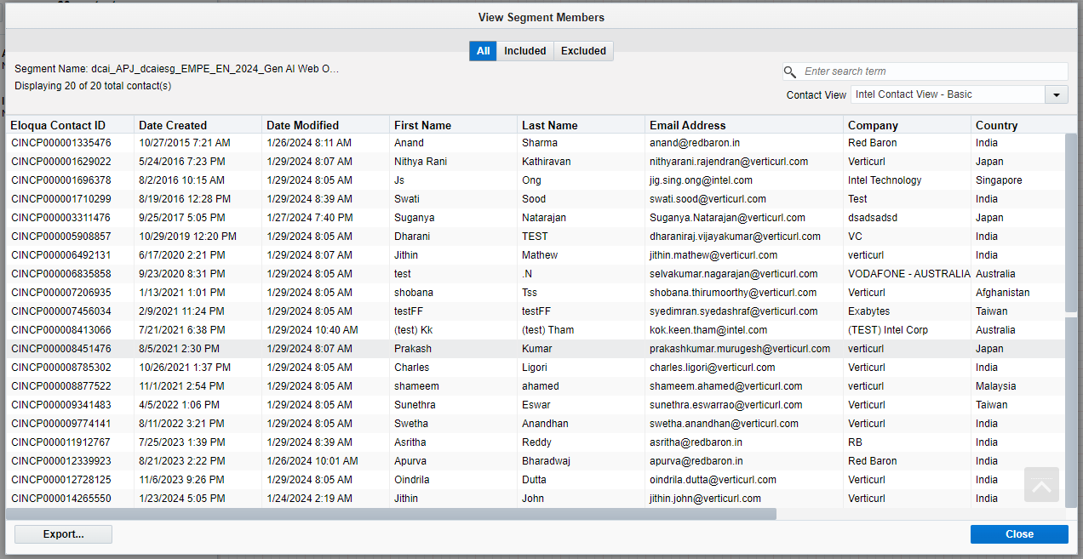

**2. Screenshot of schedule time in campaign**

**

**Seedlist Wait Step**

**Throttle Period**

**Email Scheduling**

**3. Screenshot of the Email**

**4. Screenshot of Email Preview (for 5 random contacts)**

**NA**

**5. Screenshot of the Campaign (Before schedule)­­**

**6. Screenshot of the Campaign (After schedule)­­**

**NA**